# **Book Review Portal**

## Members Of The Project:

* 1702472 Ensar Buğrahan Erdağ
* 1505453 Tolga Arslan

## The aim:

Book Review Portal consists of one database which contains all the necessary information about a review such as the name of the books and authors, categories, review text, adding date and other information about the books. The aim of this project is to allow the users to add new reviews and share their thoughts about the book they have read. This project is developed using ASP.NET MVC framework, front-end frameworks such as Bootstrap and Jquery and SQL used for back-end database during the development.

## The flow of the project:

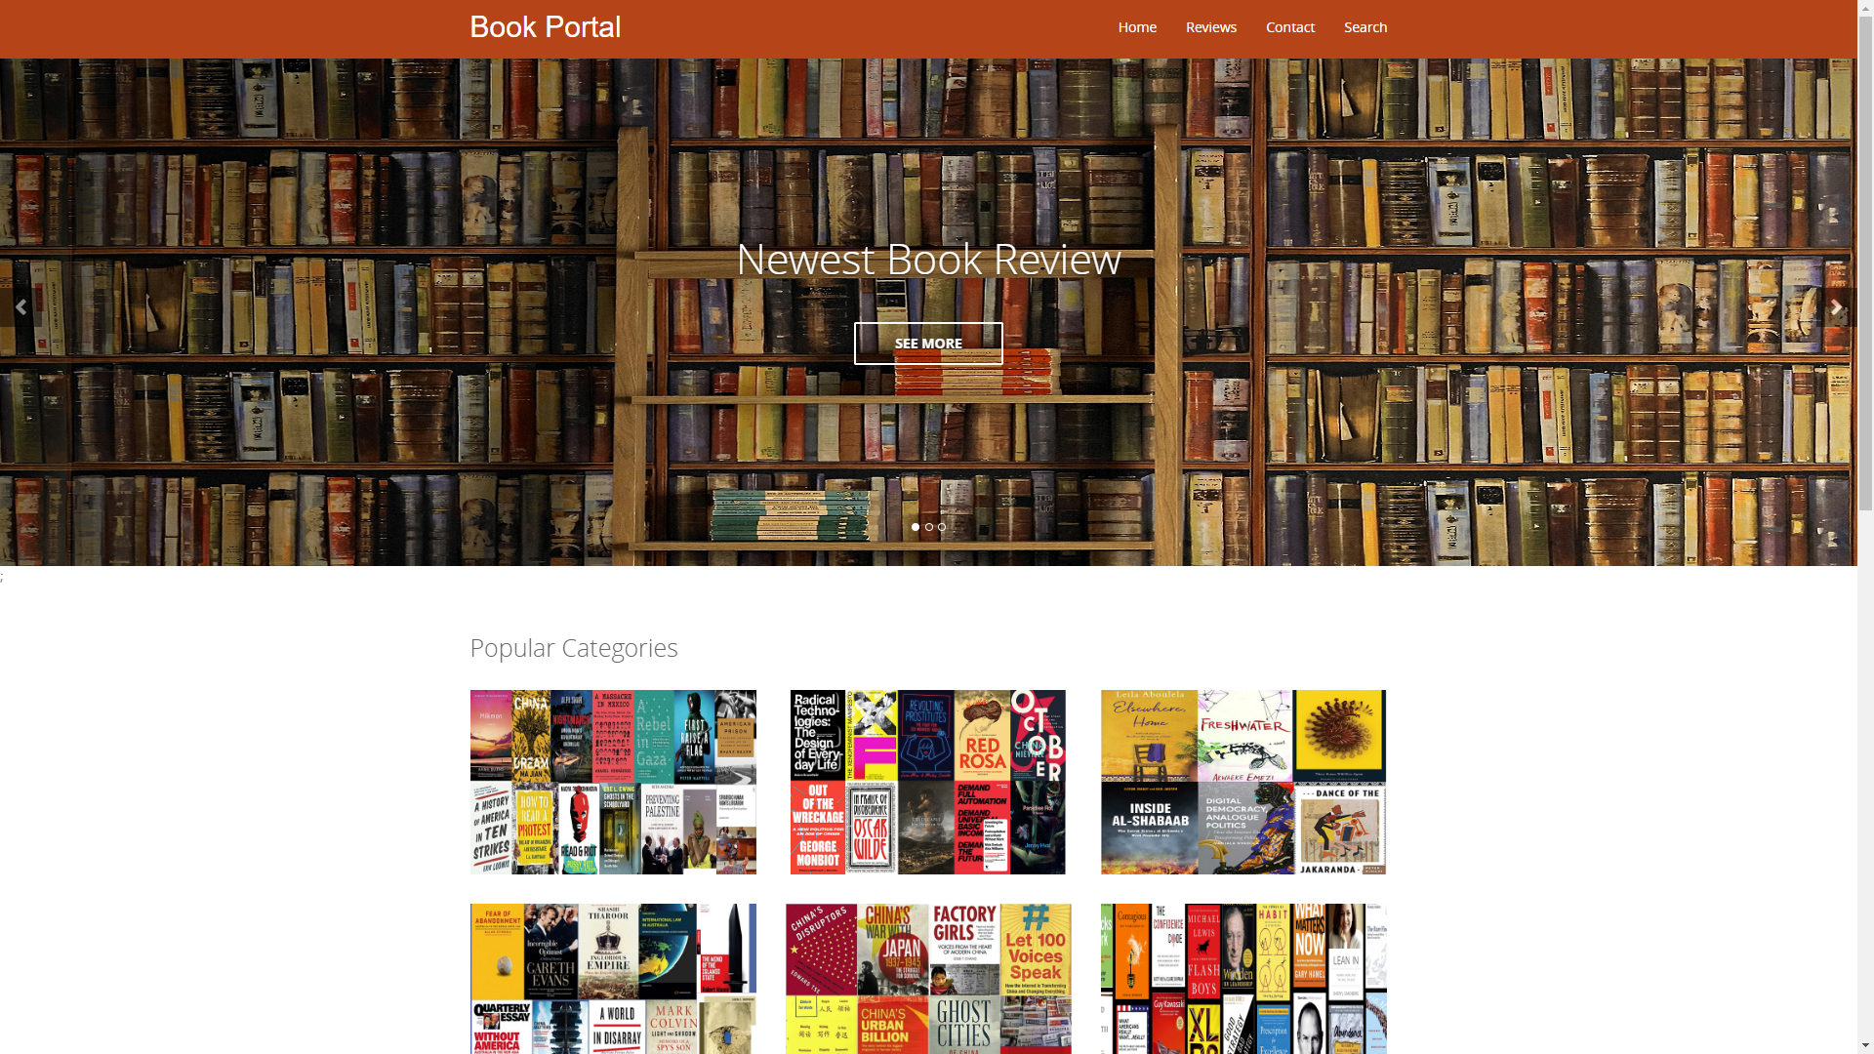

Figure Home Page

Fig 1: This is the home page of our website. The user can browse through the pages by using the top-right buttons, can see the top 5 reviews, 5 most recent reviews and the 5 oldest reviews on the website by clicking on the “See More” buttons located on the header or can click on the images under the “Popular Categories” which represent categories and upon click, they navigate the user to pages where they can display reviews filtered by the corresponding category depends on which category the user have choosen.

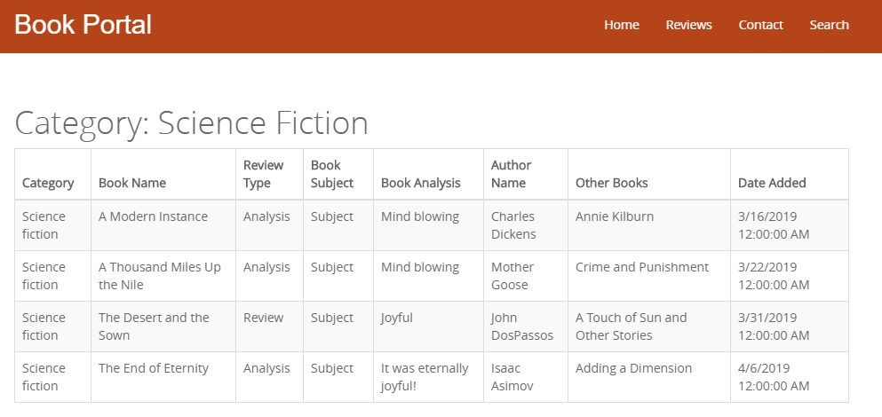

Figure Category Filtered Pages

Fig 2: After clicking on any of the 6 images under “Popular Categories”, the user will be redirected to the pages where they can read their favorite category’s book reviews.

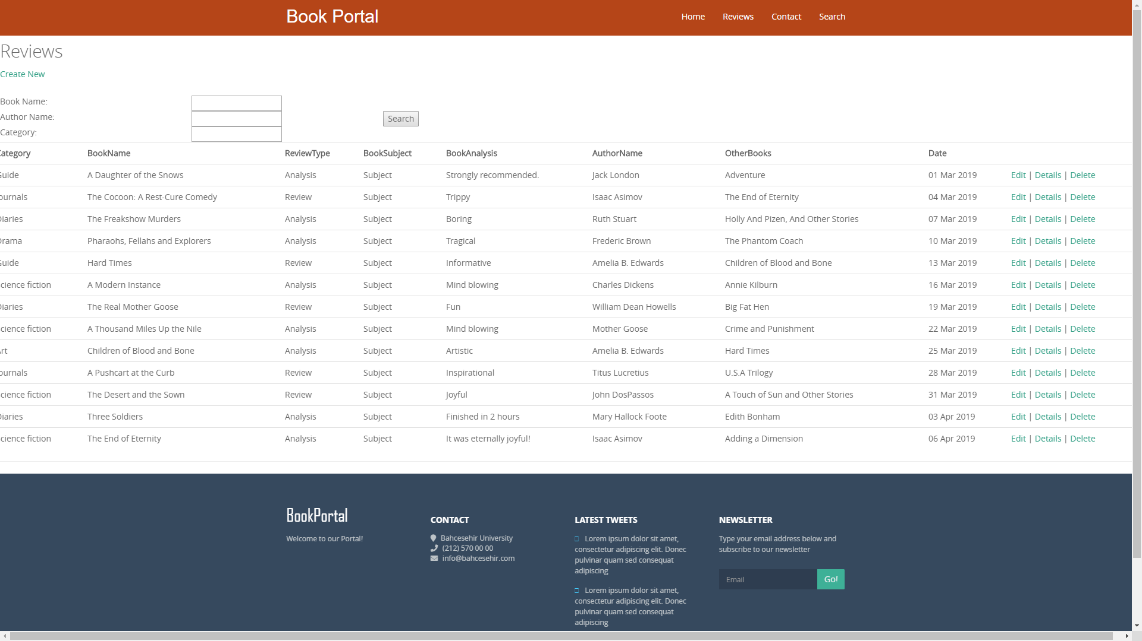

Figure Reviews Page

Fig 3: In Reviews page, the admin can display all the data stored in the database and edit, remove or add a new review.

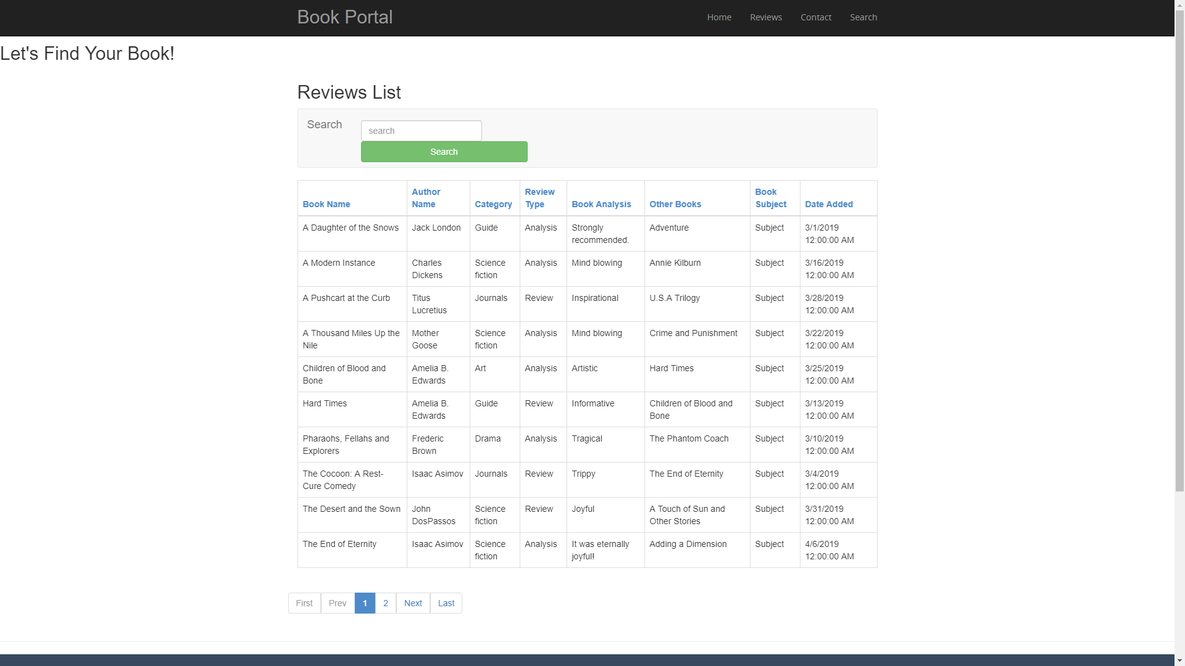

Figure Search Page

Fig 4: In Search Page, the user can find a book that s/he have on his/her mind by writing the book’s any information on the search text box and clicking on the search button. The user can also order the rows by clicking any of the columns once for A-Z and twice for Z-A.

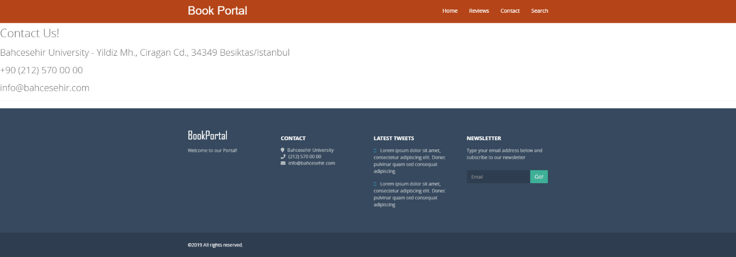

Figure Contact Page

Fig 5: The user can contact the developers by choosing one of the communication addresses displayed in this page.

# **References**

<https://docs.microsoft.com/en-us/aspnet/mvc/overview/getting-started/introduction/getting-started>